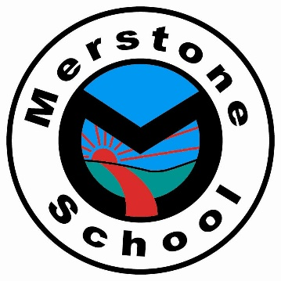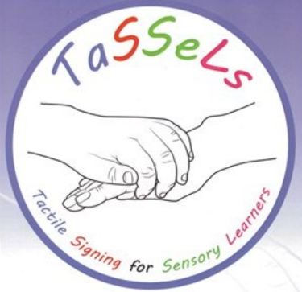

TOTAL COMMUNICATION

At Merstone School Rubies Department

The total communication approach is about finding and using the right combination of communication methods for each person. This approach helps an individual to form connections, ensures successful interactions and supports information exchanges and conversations. A combination of methods are used, which reinforce each other and strengthen meaning for the individual.
When looking at communication it is important to understand the two different types of language skills, expressive and receptive. How somebody expresses themselves can form a foundation for learning and offer a starting point on which to build communication development.
Expressive communication is when you are sending a message, this may be in response to another person or to initiate communication. Receptive communication is when you receive a message from another person. An individual’s expressive and receptive communication skills may not be the same

At Merstone our total communication approach values and uses all methods of communication so that everyone we support can communicate, understand and be understood. In the Rubies department, communication strategies are individualised and adapted for each pupil and may include but are not restricted to:

Tactile Signing for Sensory Learners (TaSSeLs)
TaSSeLs is a system of touch-speech cues to promote effective communication with people with profound and complex learning disabilities, some of whom may have a visual impairments. Touch is a vital channel of communication for learners at the earliest developmental levels.The TaSSeLs system utilises touch to promote meaningful interaction by communicating what is going to happen next and preparing learners for changes. This allows them to be involved in their own routine and offers comfort, nurture and respect. The cues are made up of a core vocabulary of everyday words used in daily routines and frequently occurring activities. When each on body sign is delivered, it is accompanied by the spoken word.

Objects of Reference
Objects of Reference is an approach that uses items to represent people, places, objects and activities alongside the spoken word. The objects can be in different forms, such as a whole object or part of an object. The objects should be relevant to the person and used consistently on every occasion. Objects of reference can also support receptive language and understanding, transition and signalling the beginning of a new activity, along with choice making.

Environmental Cues
Environmental cues inform the individual of what is occurring in the environment informing pupils of the expected reciprocated behaviour or understanding of what will happen next. Environmental cues in the Rubies department include audio song or music cues, aroma cues, people, lighting, specific room environments. Specific songs and aromas are used to signify each different day of the week, specific music is used to cue in activities, and environments are changed according to the activity occurring.

Makaton
Makaton, or “key word signing”, is a simple and easy way of communicating using signs, symbols and speech. It’s not a formal sign language. Makaton signs are based on the signs used in British Sign Language, the language of the Deaf community in the UK.
Makaton signs are used in the same grammatical order as spoken English, and together with speech, therefore you say and sign a word at the same time when using Makaton.

Intensive Interaction
Intensive Interaction is an approach to helping children and adults who are in the early stages of developing communication and social skills.
The approach is based on the way we observe and respond to the actions and noises of babies, and interpret these as communication. It helps a person and their communication partner to connect and enjoy each other’s company more.
It’s about watching closely how a child or adult responds to different situations through their body language, voice and facial expressions – and responding to this.
Intensive Interaction is two-way communication and can be used at all times in all environments.

Non-formal communication

Non-formal communication is a way to express feelings, wants and choices without speaking, writing or signing.
This can include:
- Body language.
- Changes in breathing patterns.
- Eye pointing.
- Facial expression.
- Gestures.
- Making sounds (or vocalisations).
- Pointing.

Computer-aided augmentative and alternative communication tools
Symbols used in augmentative and alternative communication (AAC) tools include gestures, photographs, symbols, letters and words. Like all methods in TOTAL communication, these can be used alone or in combination with other communication methods. AAC tools include purpose-built talking devices called voice output communication aids, talking buttons and single or multiple output communication devices such as Big Mack switches.

