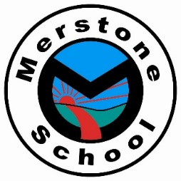

Welcome to the Ruby department
reading challenge!
Each department has a list of 60 books for you to try and read during your time in that department. Below there are tick sheets for you to keep track of how many you have read. Let your class teacher know and complete a book review when you have read a book from the Reading Challenge so they can keep track of how many you have read. Once you have read enough, you will earn a reward:

Number of books you read & review | Reward
2 | A star reader sticker
5 | A 'Reading Star' certificate
10 | A Reading star badge
20 | Head Teachers Award
40 | A free book from the school star readers’ box
60 | A £10 book voucher

Where can you get the reading challenge books from?

- In Class: You may find some of the reading challenge books on your class bookshelf.

- Local Library: Check your local library - lots of these have online reservation services too.

- Shops: You could buy the books from a shop. Check charity shops or second hand book shops first.

- Online reading services: Maybe your family have a subscription to an online reading service such as Audible, Amazon Prime - Kindle Books, etc. You might find some of the challenge books there.

- Friends and family: Ask around, maybe someone you know has that book and wouldn't mind letting you borrow it for a while.

Ruby 1 Recommended Reads
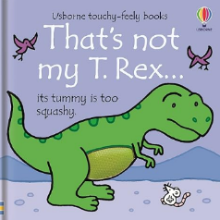 | That’s’ not my T.Rex By Fiona Watt | 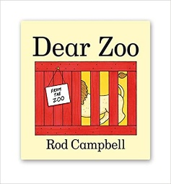 | Dear Zoo by Rod Campbell
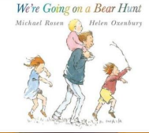 | We’re going on a bear hunt by Michael Rosen | 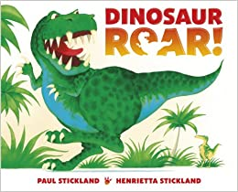 | Dinosaur Roar by Paul Stickland
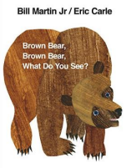 | Brown Bear, Brown Bear, What do you see? By Bill Martin Jr. & Eric Carle | 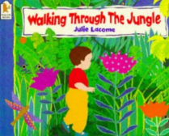 | Walking through the jungle  by Julie Lacome
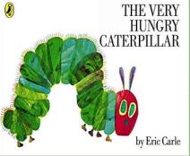 | The very hungry caterpillar by Eric Carle | 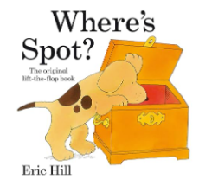 | Where’s Spot? By Eric Hill
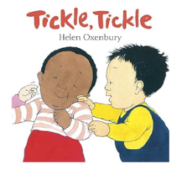 | Tickle Tickle by Helen Oxenbury | 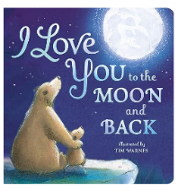 | I love you to the moon and back  By Amelia Hepworth
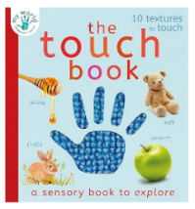 | The touch book by Nicola Edwards | 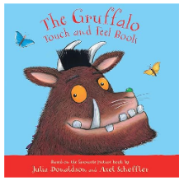 | The Gruffalo touch and feel book by Julia Donaldson
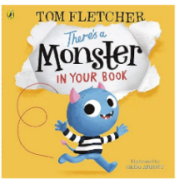 | There’s a monster in your book by Tom Fletcher | 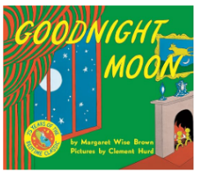 | Goodnight moon by Margaret Wise Brown
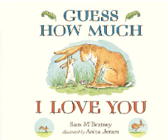 | Guess how much I love you by Sam McBratney | 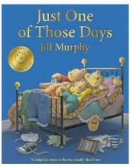 | Just one of those days by Jill Murphy
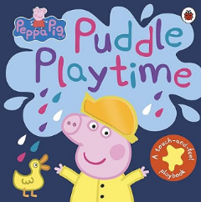 | Peppa Pig: Puddle Playtime: A Touch-and-Feel Playbook | 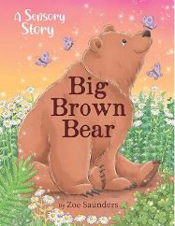 | Big brown bear by Zoe Saunders
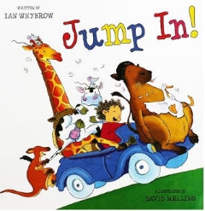 | Jump in! by Ian Whybrow | 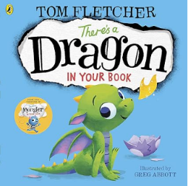 | Theres a dragon in your book by Tom Fletcher

Ruby 2 Recommended Reads
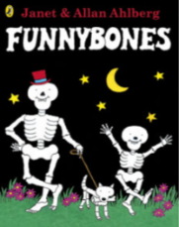 | Funnybones by Janet & Allan Ahlberg | 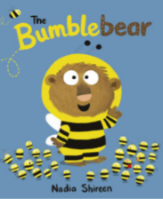 | Bumblebear by Nadia Shireen
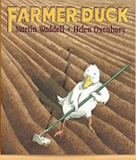 | Farmer Duck by Martin Waddell | 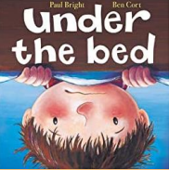 | Under the bed by Paul Bright & Ben Cort
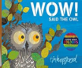 | Wow! Said the owl by Tim Hopgood | 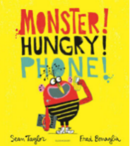 | Monster! Hungry! Phone! By Sean Taylor  & Fred Benaglia
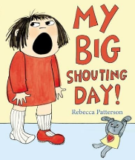 | My big shouting day!  By Rebecca Patterson | 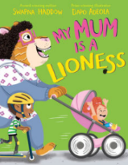 | My mum is a lioness by Swapna Haddow  & Dapo Adeola
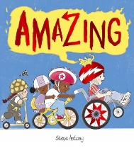 | Amazing by Steve Antony | 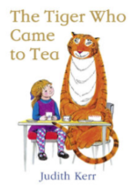 | The tiger who came to tea by Judith Kerr
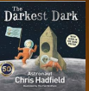 | The darkest dark by Chris Hadfield | 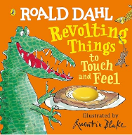 | Revolting things to touch and feel by Roald dahl
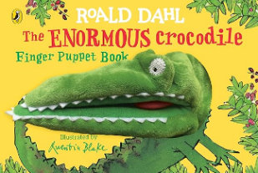 | The enormous crocodile finger puppet book by Roald Dahl | 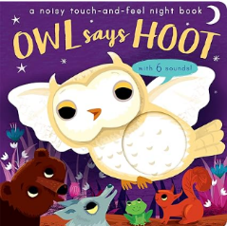 | Owl says hoot by Amanda Enright
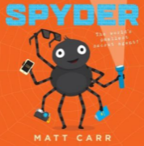 | Spyder by Matt Carr | 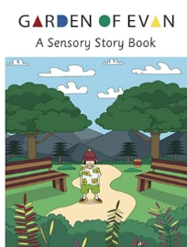 | Garden of Evan by the garden of Evan
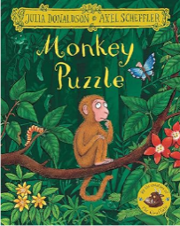 | Monkey puzzle by Julia Donaldson | 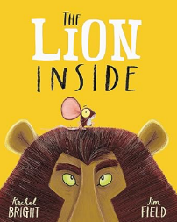 | The Lion inside by Rachel Bright
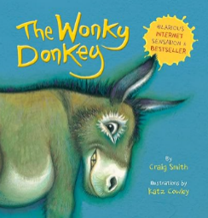 | The wonkey donkey by Craig Smith | 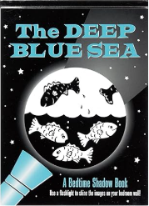 | The deep blue sea by Barbara Paulding

Ruby 3 Recommended Reads
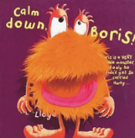 | Calm down Boris!  By Sam Lloyd | 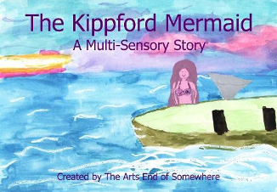 | The Kippford Mermaid by the arts end of somewhere
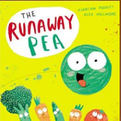 | The runaway pea by Kjartan Poskitt | 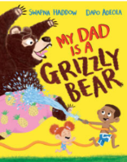 | My Dad is a grizzly bear by Swapna Haddow  & Dapo Adeola
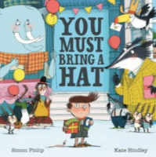 | You must bring a hat by Simon Philip & Kate Hindley | 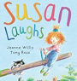 | Susan laugs by Jeanne Willis & Tony Ross
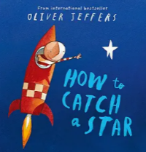 | How to catch a star by Oliver Jeffers | 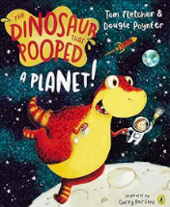 | The dinosaur that pooped a planet! By Tom Fletcher & Dougie Pointer
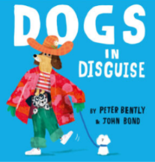 | Dogs in disguise by Peter Bently & John Bond | 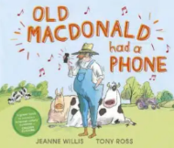 | Old Macdonald had a phone by Jeanne Willis  & Tony Ross
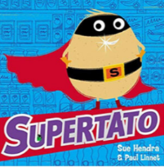 | Supertato by Sue Hendra & Paul Linnet | 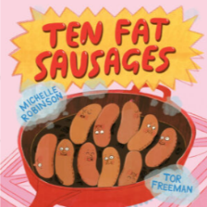 | Ten fat sausages by Michelle Robinson  & Tor Freeman
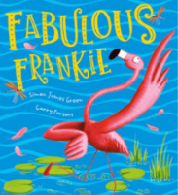 | Fabulous Frankie by Simon James Green  & Garry Parsons | 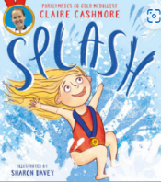 | Splash! By Claire Cashmore  & Sharon Davey
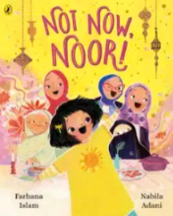 | Not now Noor! By Farhana Islam  & Nabila Adani | 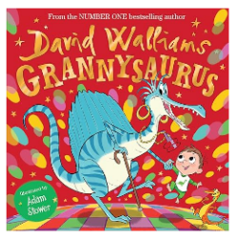 | Grannysaurus by David Walliams
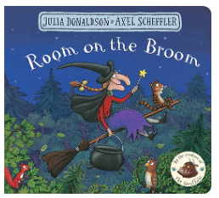 | Room on the broom by Julia Donaldson | 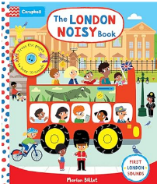 | The London noisy book by Campbell London
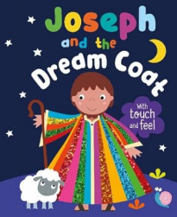 | Jospeh and the dreamcoat by Katherine Walker | 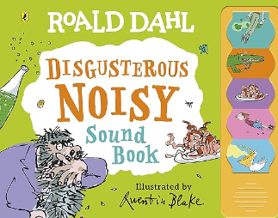 | Disgusterous noisy sound book by Roald Dahl

