
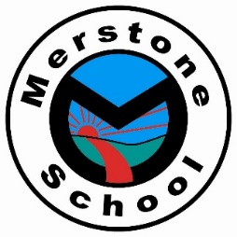
Welcome to the Emerald Department
Reading Challenge!
Each department has a list of 60 books for you to try and read during your time in that department. Below there are tick sheets for you to keep track of how many you have read. Let your class teacher know and complete a book review when you have read a book from the Reading Challenge so they can keep track of how many you have read. Once you have read enough, you will earn a reward:

Number of books you read & review | Reward
2 | A star reader sticker
5 | A 'Reading Star' certificate
10 | A Reading star badge
20 | Head Teachers Award
40 | A free book from the school star readers’ box
60 | A £10 book voucher

Where can you get the reading challenge books from?

- In Class: You may find some of the reading challenge books on your class bookshelf.

- Local Library: Check your local library - lots of these have online reservation services too.

- Shops: You could buy the books from a shop. Check charity shops or second hand book shops first.

- Online reading services: Maybe your family have a subscription to an online reading service such as Audible, Amazon Prime - Kindle Books, etc. You might find some of the challenge books there.

- Friends and family: Ask around, maybe someone you know has that book and wouldn't mind letting you borrow it for a while.

Emerald 1 recommended Reads
Dear Zoo By Rod Campbell  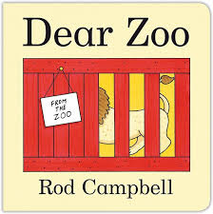 | We’re Going on a Bear Hunt By Michael Rosen  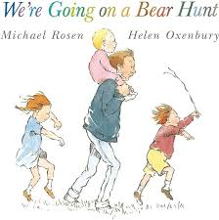 | The Very Hungry Caterpillar By Eric Carle  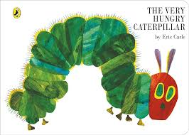 | Ten Little Fingers and Ten Little Toes By Mem Fox  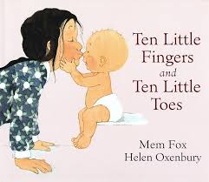
Hairy Maclary from Donaldson’s Dairy By Lynley Dodd  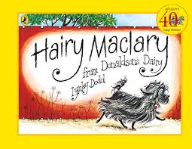 | Jasper’s Beanstalk By Nick Butterworth and Mick Inkpen  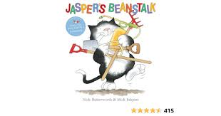 | Handa’s Surprise By Eileen Brown  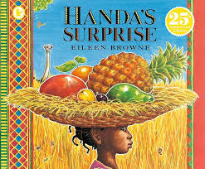 | Giraffes can’t dance By Oliver Jeffers  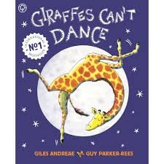
Elmer By David McKee  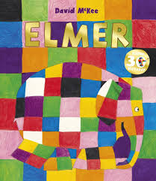 | The Paper Dolls by Julia Donaldson  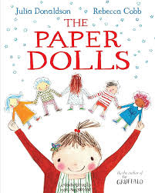 | The Gruffalo By Julia Donaldson  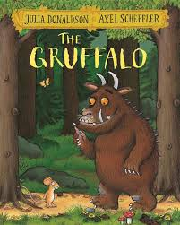 | Rosie’s Walk By Pat Hutchins  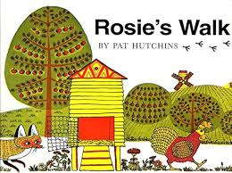
Where The Wild Things Are By Maurice Sendak  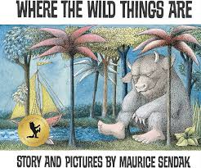 | The Tiger Who Came to Tea By Judith Kerr  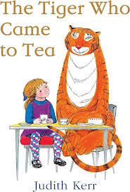 | Farmer Duck by Martin Waddell & Helen Oxenbury  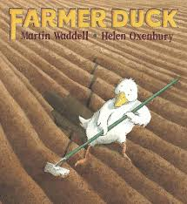 | Can’t You Sleep, Little Bear? By Martin Waddell  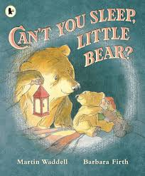
The Tiny Seed By Eric Carle  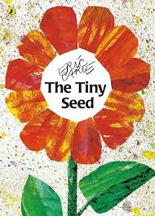 | The Elephant & the bad baby by Elfrida Vipont  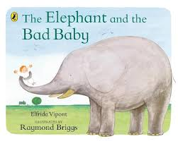 | Mr Gumpy’s outing by John Burningham  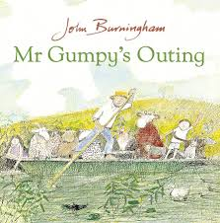 | Knuffle bunny by Mo Williams  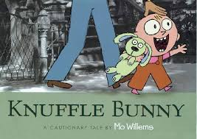
On the way home by Jill Murphy  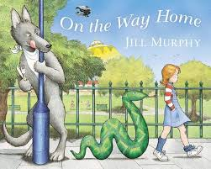 | When the rain comes by Alma Fullerton  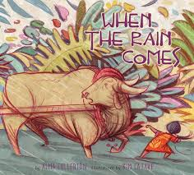 | Slug needs a hug by Jeanne Willis  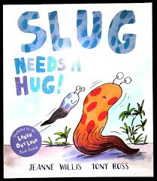 | Grandpa by John Burningham  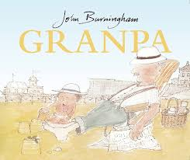
Lost and Found by Oliver Jeffers  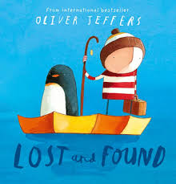 | The Day The Crayons Quit by Drew Draywait and Oliver Jeffers  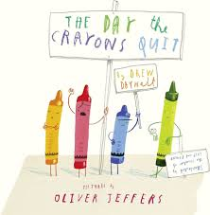 | Cops & Robbers by Janet & Allan Ahlberg  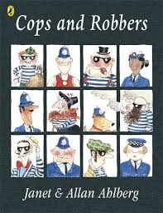 | The Smeds & the Smoos by Julia Donaldson  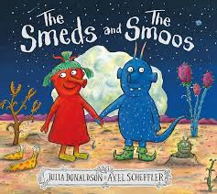

Emerald 2 Recommended Reads
The Magic Paintbrush by Julia Donaldson  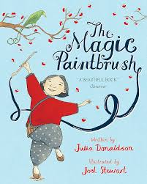 | The Boy Who Grew Dragons By Andy Shepherd  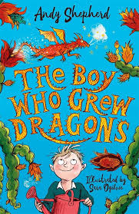 | Gangsta Granny by David Walliams  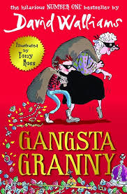 | Shhh! By Sally Grindley & Peter Utton  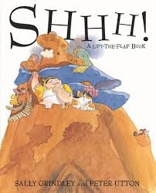
Funnybones By Allan Ahlberg  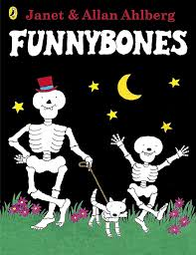 | Detective Dog – Julia Donaldson  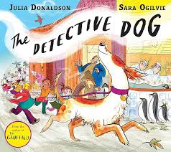 | The Snail and the Whale By Julia Donaldson  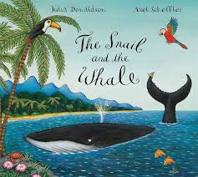 | Avocado Baby by John Burningham  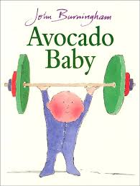
How to Wash a Woolly Mammoth By Michelle Robinson  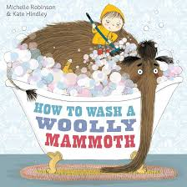 | Green eggs and ham By Dr Seuss  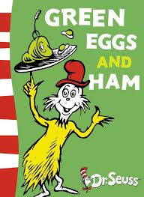 | I Will Not Ever Never Eat a Tomato By Lauren Child  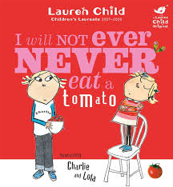 | Chocolate Cake (Poem) By Michael Rosen  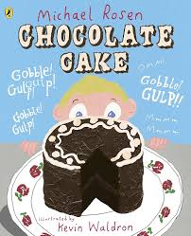
The Snowman By Raymond Briggs  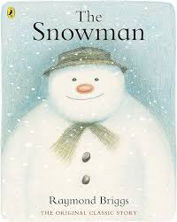 | The Rainbow Fish By Marcus Pfister  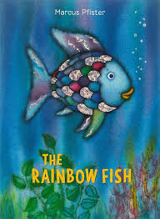 | Beegu by Alexis Deacon  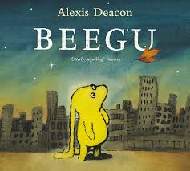 | Addicted to chicken (Poem) by Joshua Sigel. (A current Emerald 2 favourite).  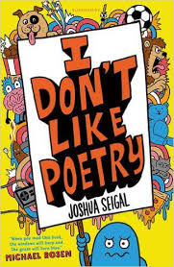

Emerald 3 Recommended Reads
The witches by Roald Dahl  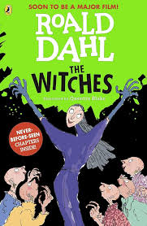 | The Owl and The Pussy-cat By Edward Lear  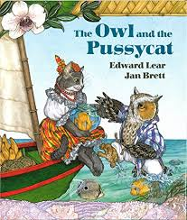 | Bringing rain to Kapati plain  By Verna Aardema  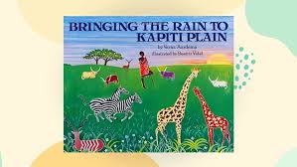 | River Boy By Tim Bowler  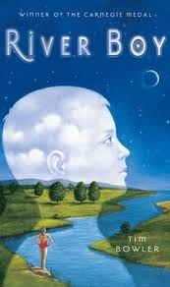
The frog prince by Jacob Grimm  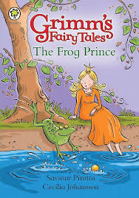 | Not now Bernard by David McKee  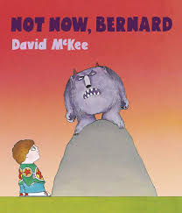 | The True Story of the 3 Little Pigs by Jon Scieszka  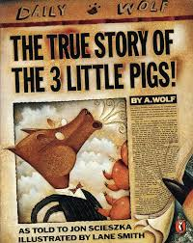 | Grandads island by Benjo Davis  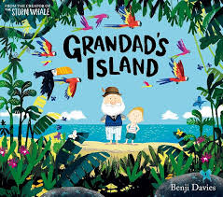
Wanted the perfect pet by Fiona Roberton  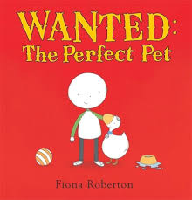 | The water princess by Susan Verde  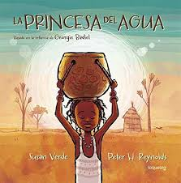 | Malas magic pencil by Malala Yousafzai  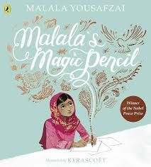 | Somebody swallowed Stanley by Sarah Roberts  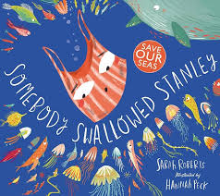
Duffys lucky escape by Ellie Jackson  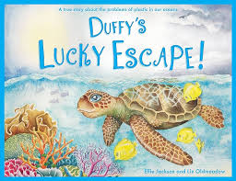 | The Queen’s Nose – Dick King Smith  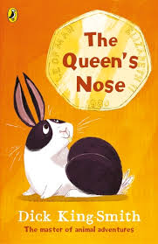 | Alice’s Adventures in Wonderland – Lewis Carroll  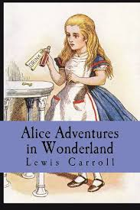 | Harry Potter and the Philosopher’s Stone– JK Rowling  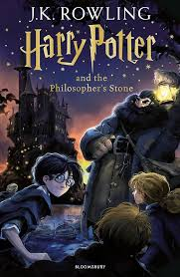
Stig of the Dump – Clive King  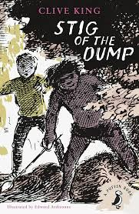 | Tom’s Midnight Garden – Philippa Pearce  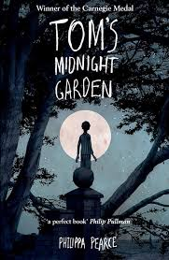 | Goodnight mr tom by Michelle Magorian  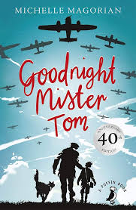 | The Midnight Gang by David Walliams  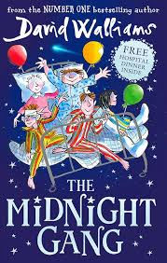
Mister Magnolia By Quentin Blake  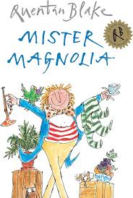 | Mrs Armitage on wheels By Quentin Blake  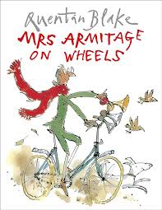 | Fantastic Mr. Fox By Roald Dahl  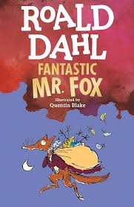 | A diary of a wimpy kid by Jeff Kinney  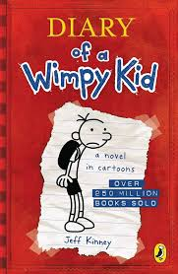
Bill’s New Frock by Anne Fine  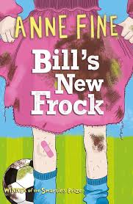 | Charlotte’s Web By E. B. White  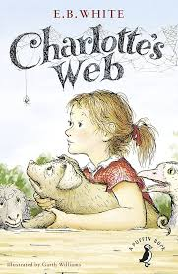 | The Iron Man By Ted Hughes  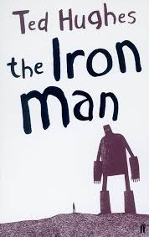 | The Accidental Prime Minister By Tom McLaughlin  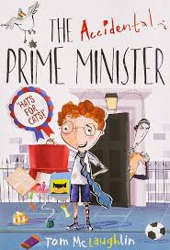
Holes By Louis Sachar  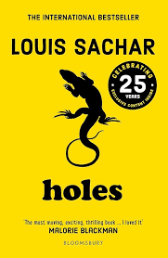 | The Hobbit By J. R. R. Tolkien  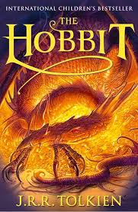 | Skellig By David Almond  

