Merstone School
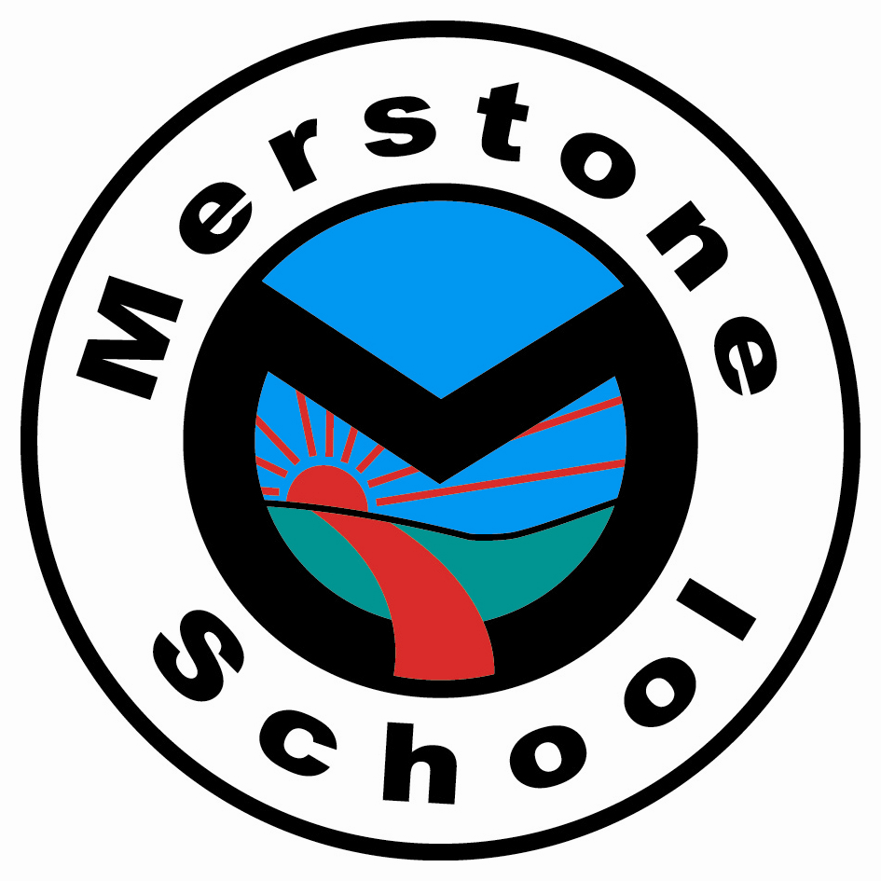

EYFS Scheme of Work

July 2024 – J Russell

Introduction
The EYFS Scheme of Work works towards the statutory guidelines of the Early Years Foundation Curriculum. Merstone’s EYFS commitments to the curriculum and how it achieves these is explored in greater detail in the EYFS Policy.
Each of Merstone’s EYFS classes follow the Early Years Foundation Stage Curriculum which is made up of seven areas of learning and development. All areas are interconnected with each other, with activities therefore being delivered as cross-curricular sessions. The children’s progress is plotted throughout and at the end of the Foundation Stage using the Merstone Learning Through Play assessment framework and The Early Years Profile. Assessments are moderated in a variety of ways to ensure assessment is accurate. How assessment is conducted in the EYFS is explained in greater detail in the document ‘Assessment in Merstone Early Years Foundation Stage’.
The rolling Scheme of Work covers a two-year period (nursery and reception). EYFS sessions are delivered using a thematic approach guided by staff and pupils using the Early Years Foundation Stage development matters (https://assets.publishing.service.gov.uk/government/uploads/system/uploads/attachment_data/file/1007446/6.7534_DfE_Development_Matters_Report_and_illustrations_web__2_.pdf) and the statuary framework for the early years foundation stage (https://assets.publishing.service.gov.uk/government/uploads/system/uploads/attachment_data/file/974907/EYFS_framework_-_March_2021.pdf) as a guide. Planning is child specific and marries the objectives from the Scheme of Work with the information from EYFS data and assessment tracking systems. Class teams are encouraged to evaluate activities and consider objectives for following sessions. This also allows pupils to lead their own learning by inputting ideas or comments which can then influence the activities for future sessions.
Children who enter the EYFS earlier than their nursery year will be offered activities on an individual needs basis.
The seven areas of learning are outlined below:
3 Prime areas:
Communication, and Language
- Listening and attention, understanding, and speaking

Physical Development
- Moving and handling, health and self care

Personal, Social and Emotional Development
- Self Confidence and Self Awareness, Managing feelings and behaviour, and Making Relationships

4 specific areas, through which the three prime areas are strengthened and applied:
Literacy
- Reading, and Writing

Mathematics
- Numbers, and Shape, Space and Measures.

Understanding the World
- People and Communities, The World, and Technology

Expressive Arts and Design
- Exploring and Using Media and Materials, and Being Imaginative

Merstone School
EYFS Thematic Focus Cycle
Term |  | Pebbles  (Toddlers/Pre-Nursery/ Nursery) | Reception  (Reception aged pupils inlcuding any EYFS pupils educated within Key Stage 1)
Year 1 | Autumn | Dazzling diggers  5 current buns  The Windy day  Brown bear what do you see? | Elmer  We’re going on a leaf hunt  Space – Whatever next  Gruffalo
Year 1 | Spring | Wheels on the bus  Old McDonald  The very busy spider  Peppa’s Easter | Topsy + Tim – People who help us  Goldilocks  Snail + Whale  Commotion in the ocean
Year 1 | Summer | My first book of smells + colours/ mary mary  Walking through the jungle  Pupil interest: Fireman Sam  Tip tap went the crab | Farm (A squash and a squeeze  /Farmer duck  /Noisy farm)  Under the sea (Pirates/ under the sea)
Year 2 | Autumn | Head, shoulders, knees + toes  Row your boat  Leaf man  We’re going on a bear hunt  Pupil interest: Peppa pig  The nativity | Elmer  We’re going on a leaf hunt  Room on the broom  Supertato
Year 2 | Spring | To town  The very hungry caterpillar  Dear Zoo  We’re going on an egg hunt | We’re going on a bear hunt  3 little pigs  Tiddler  The golden egg
Year 2 | Summer | Dinosaur roar  Miss Polly had a dolly  Pupil interest: Mr Tumble  Lets go to the seaside | Dinosaurumpus  Travelling (We all go travelling/To Town)  Olivers Vegetables/ fruit salad  Pirates

Celebrations and Festivals
Autumn | Spring | Summer
Christmas  Eid  Bonfire Night  Diwali  St Andrews Day  Remembrance | Chinese New Year  St Davids Day  Shrove Tuesday  Mothering Sunday  St. Patricks Day  Easter | St Georges Day  Fathers Day  Eid

