
Welcome to the Diamond department
The Diamond department at Merstone School caters for students aged 14 – 19 years. Students in our Diamond department have a range of needs. To ensure we allow all students to have access to a curriculum that suits individual needs our department consists of 3 classes. Diamond 1 class supports our students who have sensory and complex learning needs. Diamond 2 class supports our students who require a curriculum that requires a hands on practical approach to learning and our Diamond 3 class supports our students that are working at a higher academic level and require a more structured ‘work’ based environment. We appreciate the need for all students to feel they are integrated in our department so ensure we, as a department, join together as often as possible. Joint activities take place during SMILE activities each week, Star assembly each week where we all come together to share achievements that have happened over the week or term and we also ensure students have an opportunity to enjoy social time together at break times and lunch times.

The Diamond Curriculum
Much of our curriculum in the Diamond department has been designed to support the students as they prepare for adulthood and life after Merstone School. Our aim is to ensure we teach and embed many of the necessary skills our students will need to become active and happy members of their community. Our curriculum is built using a range of ASDAN Towards Independence modules, ASDAN Transition Challenge modules, some of our lessons are taken from the Equals scheme of work and some of our students in the Diamond 2 and 3 class will also take part in Ascentis exams. Much of our work is collected and internally moderated as students’ progress through our department and is then sent off for external moderation when the students reach the end year 14. The units have been selected to enhance the learning experiences of the students and deliver all aspects of the curriculum at a level appropriate to their cognitive ability. Lessons are planned to ensure students are given exciting opportunities to participate in and enjoy the learning process, build on prior knowledge whilst using and extending their individual skills.

The Diamond timetable
Timetables provide consistency and stability. Structuring the day into sessions can help enable learners to know what is happening and predict what is coming next (Fox et al., 2020). Predictability and routine create a sense of safety and security. Predictability also helps learners develop a sense of self and an increased understanding of their environment (Watson et al., 2016). Each of the classes in the Diamond department have their own timetable to suit the needs of the students, students in our Diamond 1 class have daily sensory diet sessions as this has been shown to support them in preparing for the school day, many of our students in Diamonds 1 also have access to weekly swimming sessions to support their physio, fitness and behavioural needs. All students in our department have an opportunity to take part in fortnightly educational visits as we believe this enables them to put into practice what they have been taught in the classroom and supports them in preparing for adulthood. Students in our Diamond 2 and 3 class also attend weekly educational visits to take part in sporting activities such as golf, Ackers and bowling. This supports their understanding of keeping themselves physically and mentally healthy whilst enabling them to practice those important social skills and how to stay safe in their community. During the spring term, all pupils in our department are encouraged to make a work experience plan, taking into account what they enjoy and what they think they would like to do as a future career. Some of our students will then take part in weekly school based work experience opportunities whilst others will take part in work experience opportunities with local businesses.

Timetable examples
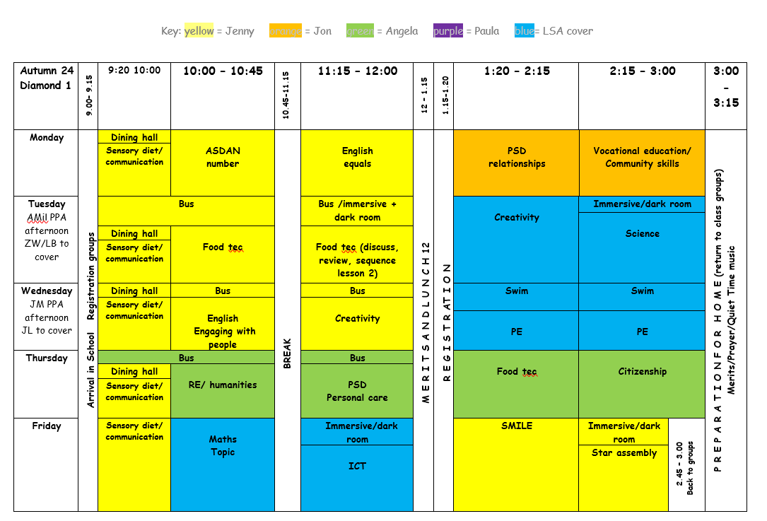
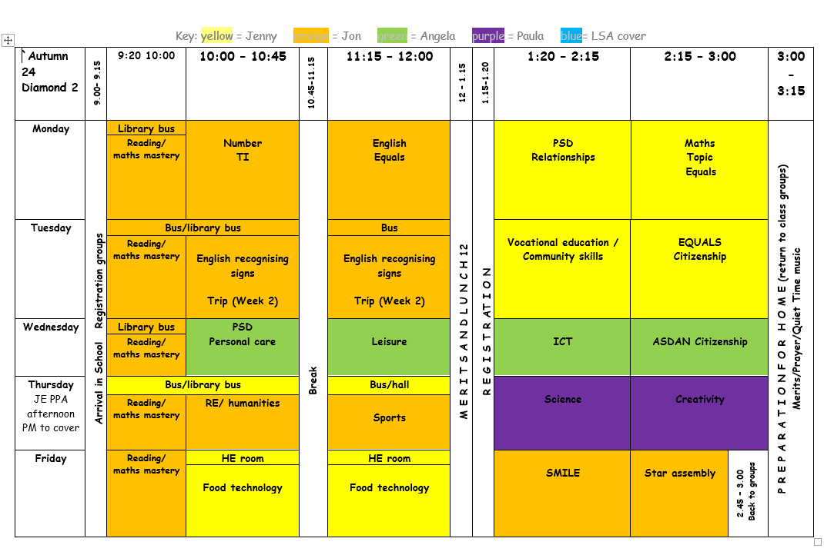
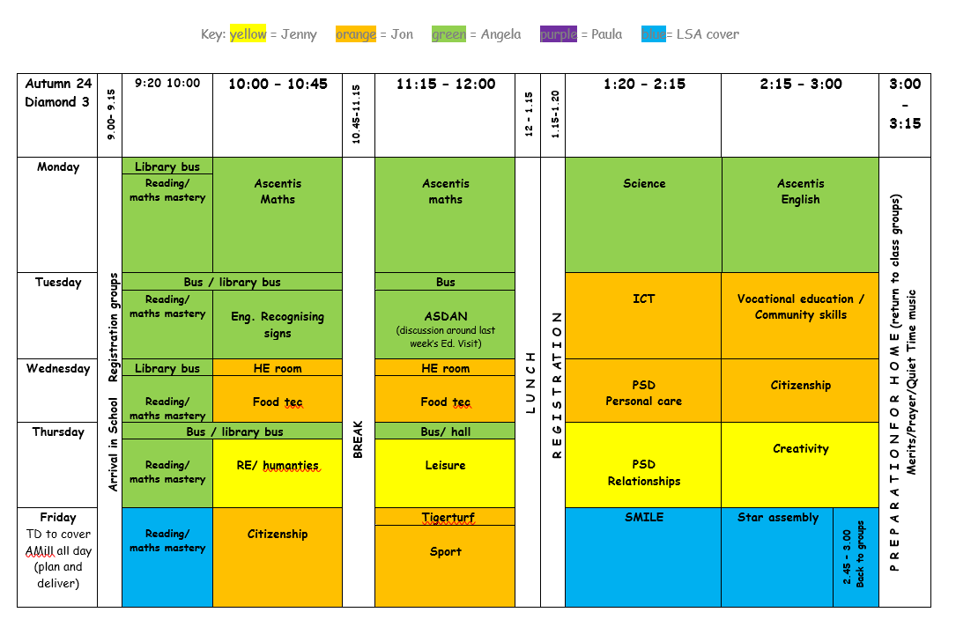

Planning in the Diamond department
Planning in the Diamond department is based on the individual needs of the students and ensures there is a good mix of exciting opportunities for students to experience and engage with at a level to suit their needs. This includes daily sensory diet sessions for those students that have been identified by the occupational therapist as needing this input, maths mastery for students in our Diamond 2 and 3 class to embed those important early maths ‘thinking’ skills and individual speech and language targets to suit each student’s need. All of our lessons are planned to support and develop communication at all levels of academic ability.
A long term overview has been developed by the department lead and is a starting point for teachers when producing their medium term plans which are produced half termly.

Curriculum coverage
All students in our Diamond department have access to twenty-five lessons per week, please refer to weekly timetables above to see our weekly curriculum coverage.

Assessment in the Diamond department
Within the Diamond department, students learning and experiences are recorded through staff observations, photographs, videos and physical pieces of work. Observations highlight what happened within an activity and are linked to assessments that demonstrate how the students’ skills and understanding develop in relation to their individual targets and learning needs. The Earwig app is used to digitally record progress and is completed at regular intervals by all staff in the department and shared with students, families and staff to celebrate students’ progress. Work is collected and prepared for external moderation where appropriate, this allows school staff and outside external moderators to assess ASDAN qualifications and Ascentis exams taken by individual students in the department. All of these documents will build a profile of experiences to share with parents at parents evening and with other professionals including colleges and post 19 placements to support transition post 19.



